

Packet Tracer - Configuring DHCP Using Cisco IOS

## Topology

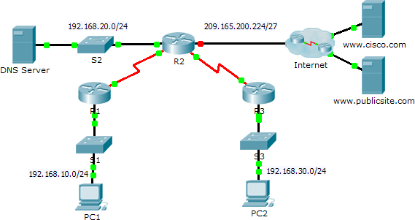

**Addressing Table**

|  |  |  |  |  |
| --- | --- | --- | --- | --- |
| **Device** | **Interface** | **IPv4 Address** | **Subnet Mask** | **Default Gateway** |
| R1 | G0/0 | 192.168.10.1 | 255.255.255.0 | N/A |
| S0/0/0 | 10.1.1.1 | 255.255.255.252 | N/A |
| R2 | G0/0 | 192.168.20.1 | 255.255.255.0 | N/A |
| G0/1 | DHCP Assigned | DHCP Assigned | N/A |
| S0/0/0 | 10.1.1.2 | 255.255.255.252 | N/A |
| S0/0/1 | 10.2.2.2 | 255.255.255.252 | N/A |
| R3 | G0/0 | 192.168.30.1 | 255.255.255.0 | N/A |
| S0/0/1 | 10.2.2.1 | 255.255.255.0 | N/A |
| PC1 | NIC | DHCP Assigned | DHCP Assigned | DHCP Assigned |
| PC2 | NIC | DHCP Assigned | DHCP Assigned | DHCP Assigned |
| DNS Server | NIC | 192.168.20.254 | 255.255.255.0 | 192.168.20.1 |

**Objectives**

#### Part 1: Configure a Router as a DHCP Server Part 2: Configure DHCP Relay

**Part 3: Configure a Router as a DHCP Client Part 4: Verify DHCP and Connectivity**

**Scenario**

A dedicated DHCP server is scalable and relatively easy to manage, but can be costly to have one at every location in a network. However, a Cisco router can be configured to provide DHCP services without the need for a dedicated server. As the network technician for your company, you are tasked with configuring a Cisco router as a DHCP server to provide dynamic allocation of addresses to clients on the network. You are also required to configure the edge router as a DHCP client so that it receives an IP address from the ISP network.

# Part 1: Configure a Router as a DHCP Server

### Step 1: Configure the excluded IPv4 addresses.

Configure **R2** to exclude the first 10 addresses from the R1 and R3 LANs. All other addresses should be available in the DHCP address pool.

### Step 2: Create a DHCP pool on R2 for the R1 LAN.

1. Create a DHCP pool named **R1-LAN** (case-sensitive).
2. Configure the DHCP pool to include the network address, the default gateway, and the IP address of the DNS server.

### Step 3: Create a DHCP pool on R2 for the R3 LAN.

1. Create a DHCP pool named **R3-LAN** (case-sensitive).
2. Configure the DHCP pool to include the network address, the default gateway, and the IP address of the DNS server.

# Part 2: Configure DHCP Relay

### Step 1: Configure R1 and R3 as a DHCP relay agent.

**Step 2: Set PC1 and PC2 to receive IP addressing information from DHCP.**

**Part 3: Configure R2 as a DHCP Client**

1. Configure the Gigabit Ethernet 0/1 interface on R2 to receive IP addressing from DHCP and activate the interface.

**Note**: Use Packet Tracer’s **Fast Forward Time** feature to speed up the process or wait until R2 forms an EIGRP adjacency with the ISP router.

1. Use the **show ip interface brief** command to verify that R2 received an IP address from DHCP.

# Part 4: Verify DHCP and Connectivity

### Step 1: Verify DHCP bindings.

#### R2# show ip dhcp binding

|  |  |  |  |  |
| --- | --- | --- | --- | --- |
| IP address | Client-ID/  Hardware address | Lease | expiration | Type |
| 192.168.10.11 | 0002.4AA5.1470 | -- |  | Automatic |
| 192.168.30.11 | 0004.9A97.2535 | -- |  | Automatic |

**Step 2: Verify configurations.**

Verify that **PC1** and **PC2** can now ping each other and all other devices.